**Developing a Backend Admin for Learner’s Academy**

**Developer: Kamar Zaghloul**

1. **Info**

* FSD 2021 (Vodafone)
* **Developer**: Kamar Zaghloul
* **GitHub Repo**:

<https://github.com/kamarz01/Simplilearn_Phase2_Learners_Acadmy_Admin_Backend>

1. **Introduction**

**Project objective:**

As a Full Stack Developer, design and develop a backend administrative portal for the Learner’s Academy. Use the GitHub repository to manage the project artifacts.

**Background of the problem statement:**

Learner’s Academy is a school that has an online management system. The system keeps track of its classes, subjects, students, and teachers. It has a back-office application with a single administrator login.

1. **Project Planning**
   * + - The project is to be completed in two sprints.
       - The resources available for this project is (2):

1 Developer & 1 Tester.

**Sprint (1) will include:**

* + - * Create application design.
      * Create project skeleton.
      * Setup project configurations.
      * Create database schema.
      * Design project UI screens.
      * Implement Classes CRUD feature.
      * Implement Subjects CRUD feature.
      * Implement Teachers CRUD feature.
      * Implement Student CRUD feature.

**Sprint (2) will include:**

* + - * Implement Assign subject to class feature.
      * Implement Assign student to class feature.
      * Implement Assign teacher to class feature.
      * Implement Assign teacher to subjects feature.
      * Create class report design.
      * Implement Class Report feature.
      * Creating documentations.
      * Pushing project to GitHub.

1. **Technologies & Concepts used in Project**
   * + - Java EE
       - Servlets
       - JSP
       - Hibernate
       - MySql
       - HTML5
       - CSS3
       - JSTL
       - JSP EL
       - Listeners
       - Exception Handling
       - OOP
       - Collections
       - Streams
       - Data Structures

and more...

1. **Application Entities**

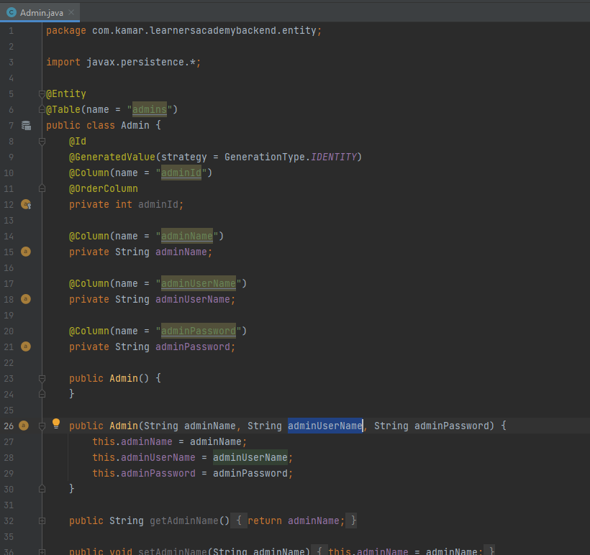

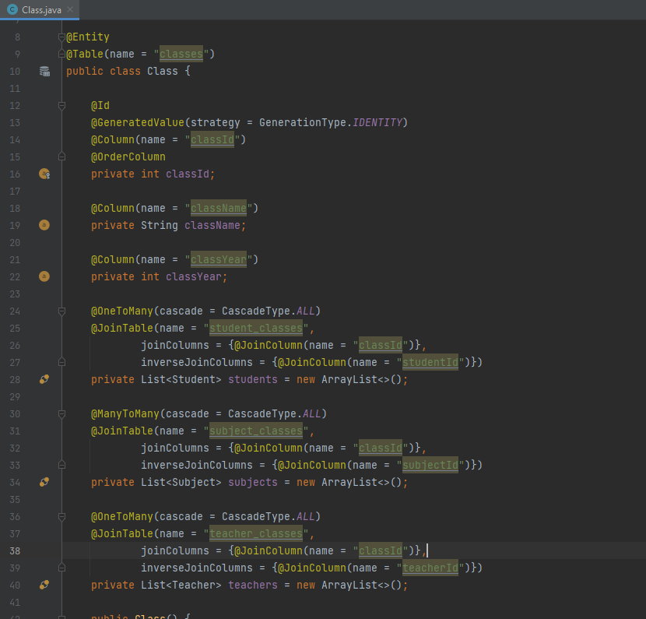

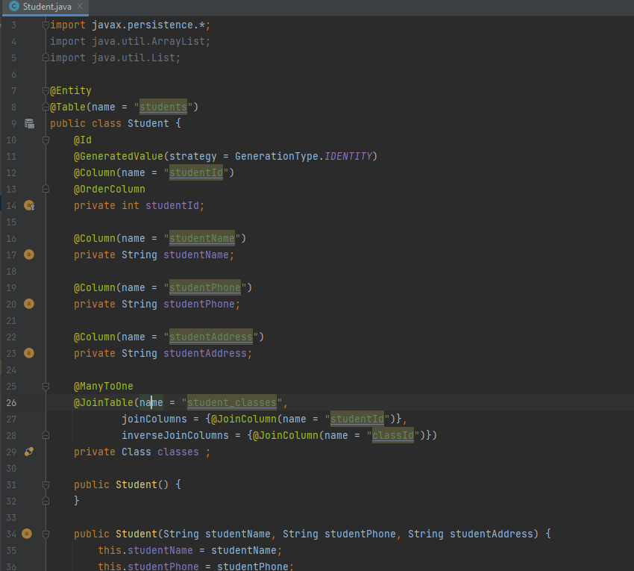

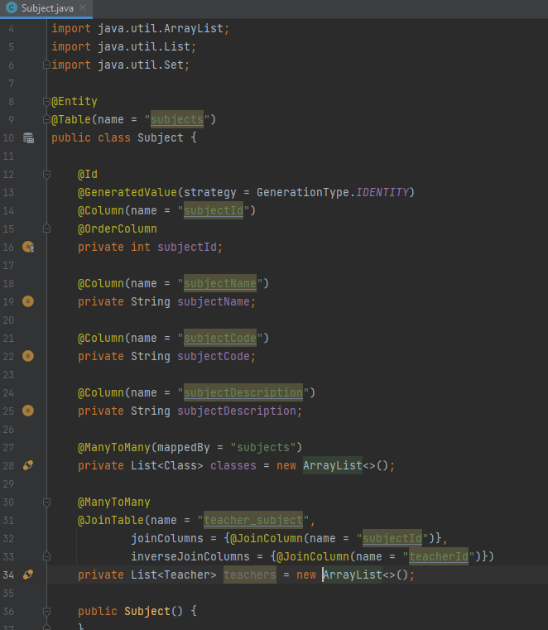

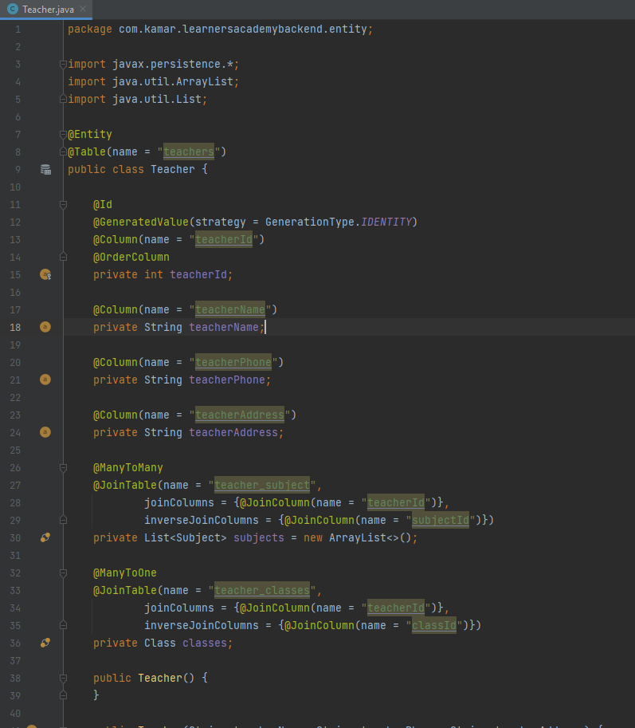

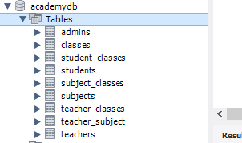

1. **Project Structure**

The project was been created following a good design structure to separate the logic from the user interface.

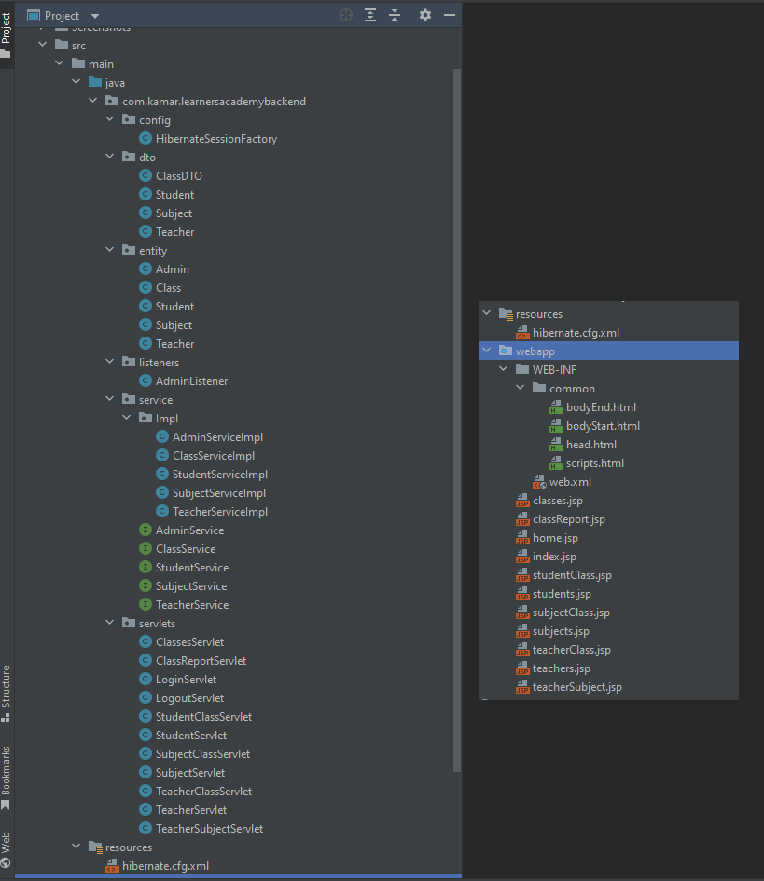

1. **ERD**

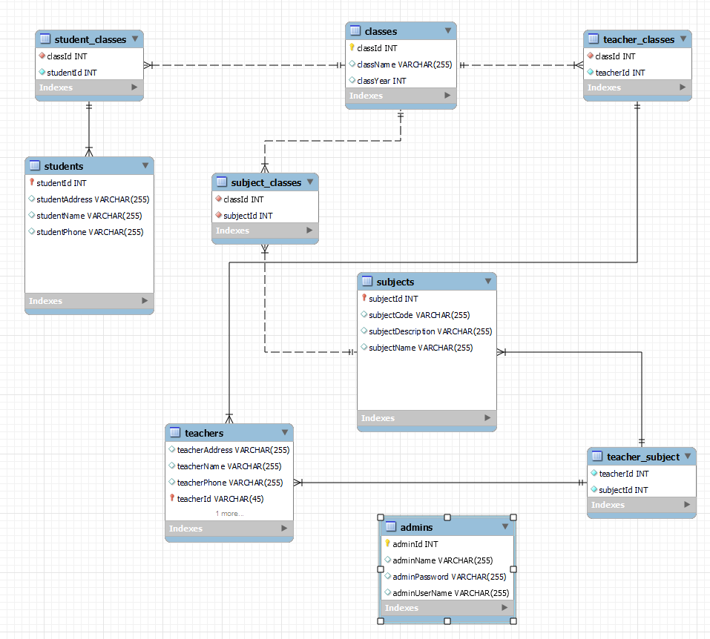

1. **Create Admin user If does not exist**

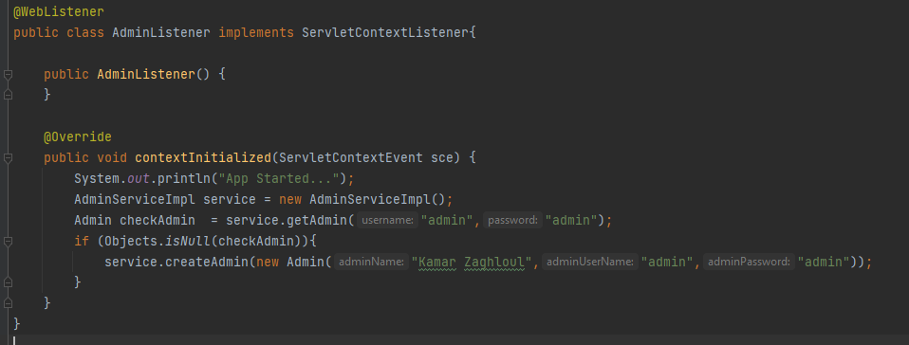

1. **Application Demo**

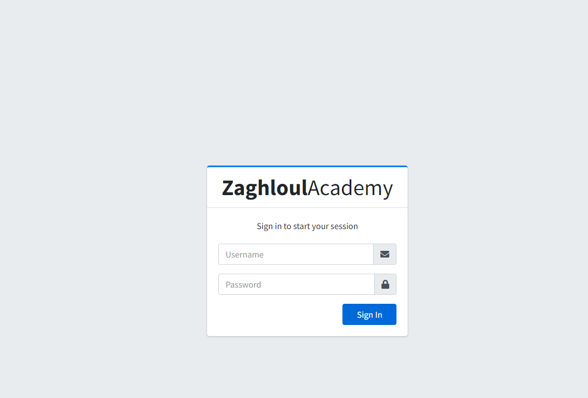

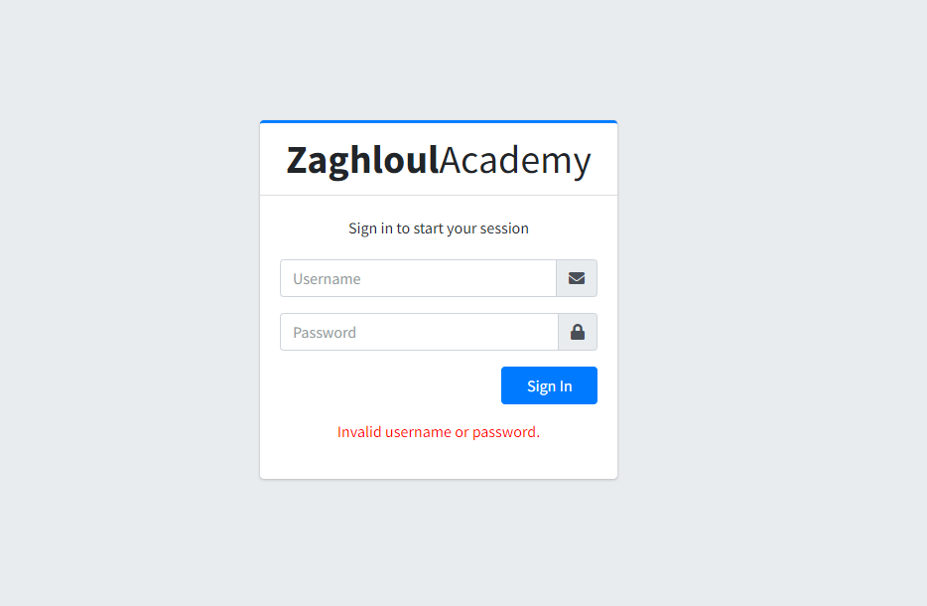

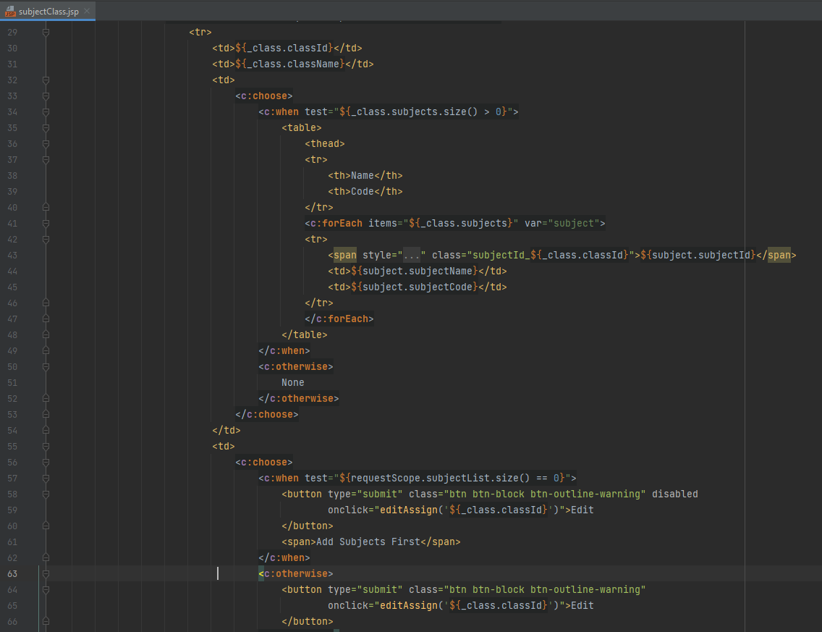

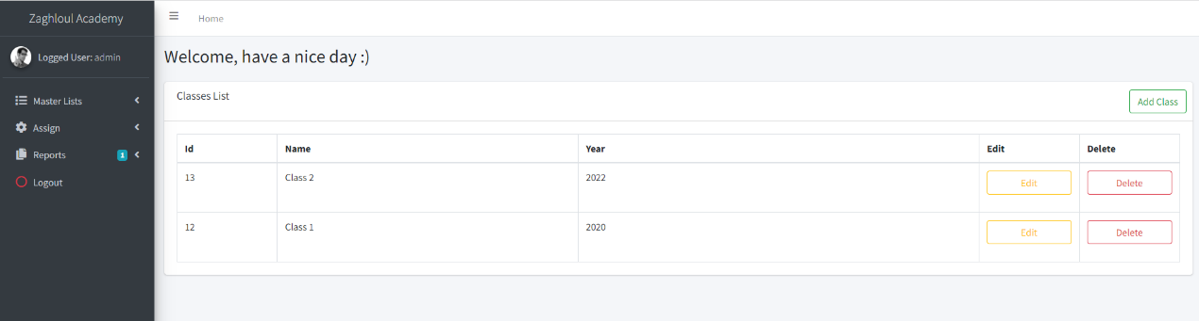

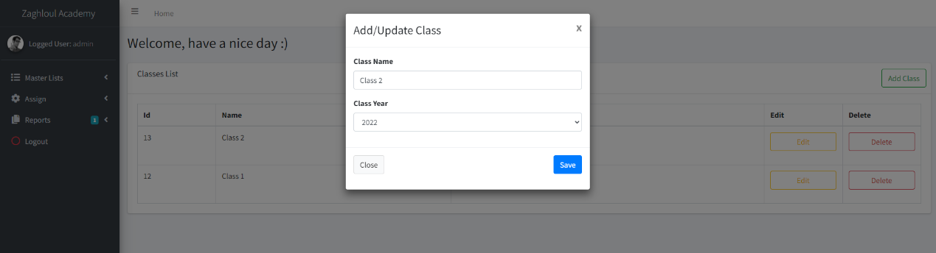

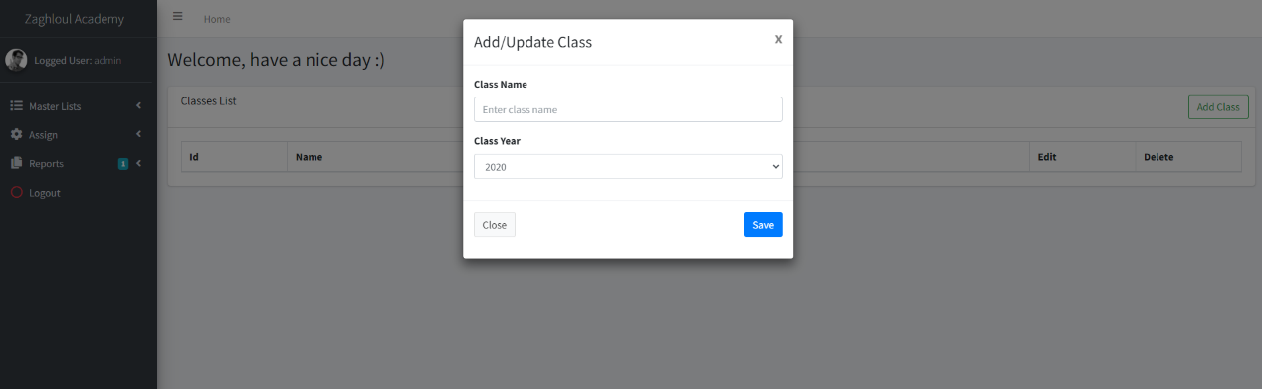

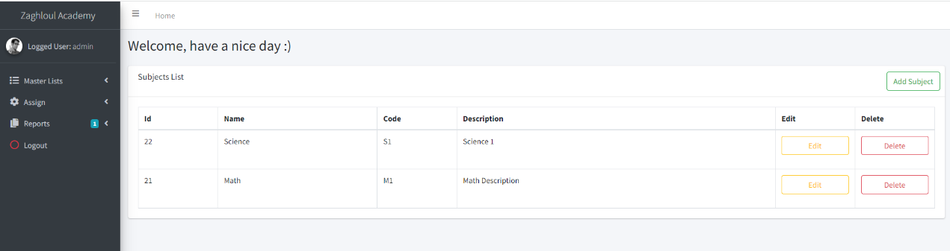

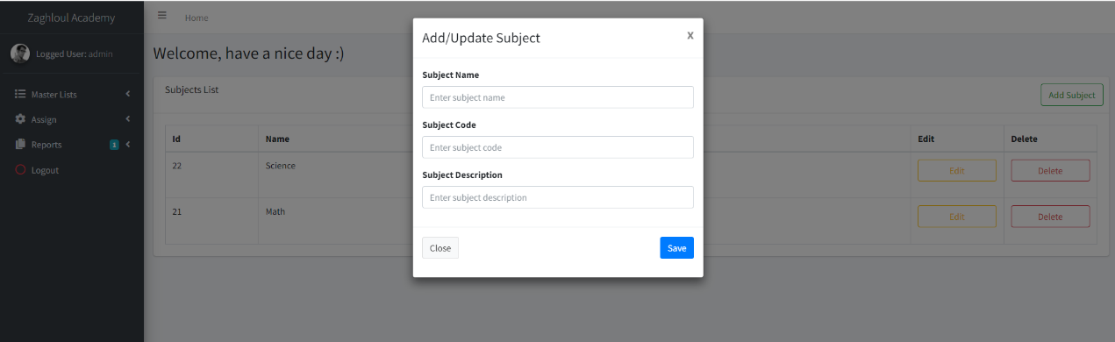

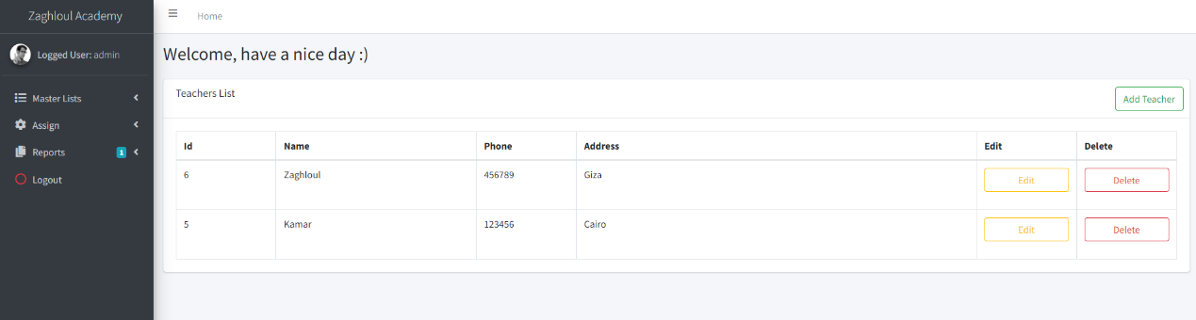

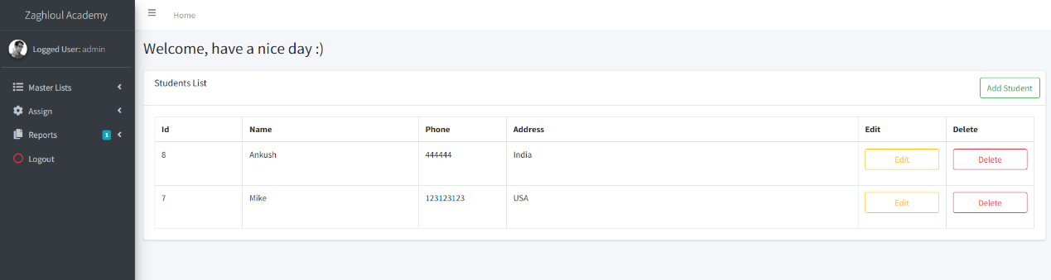

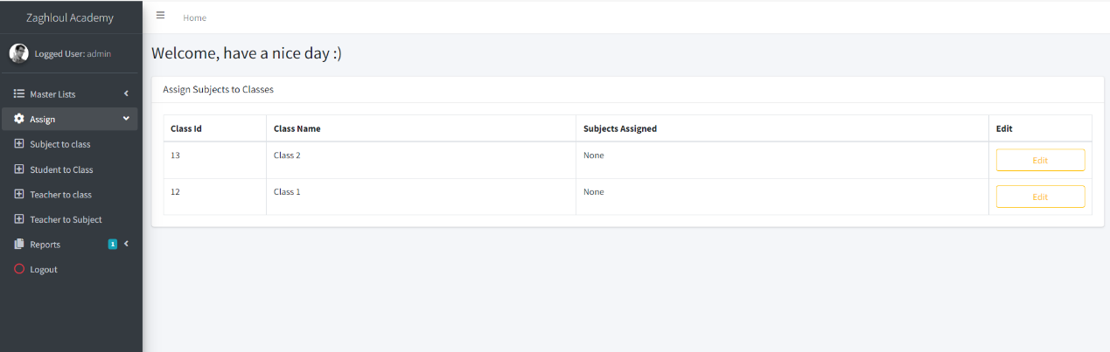

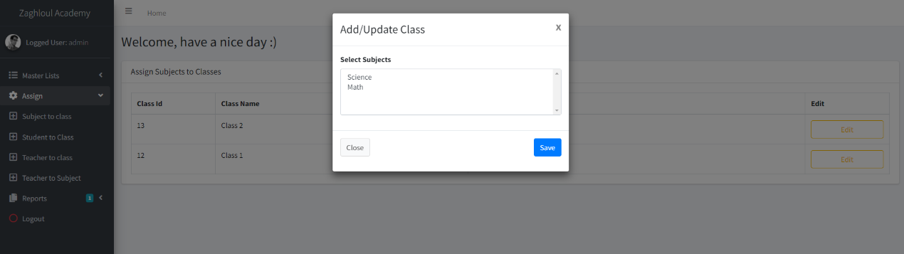

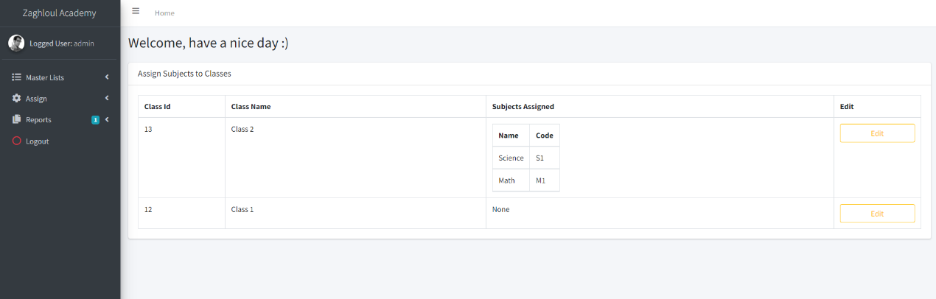

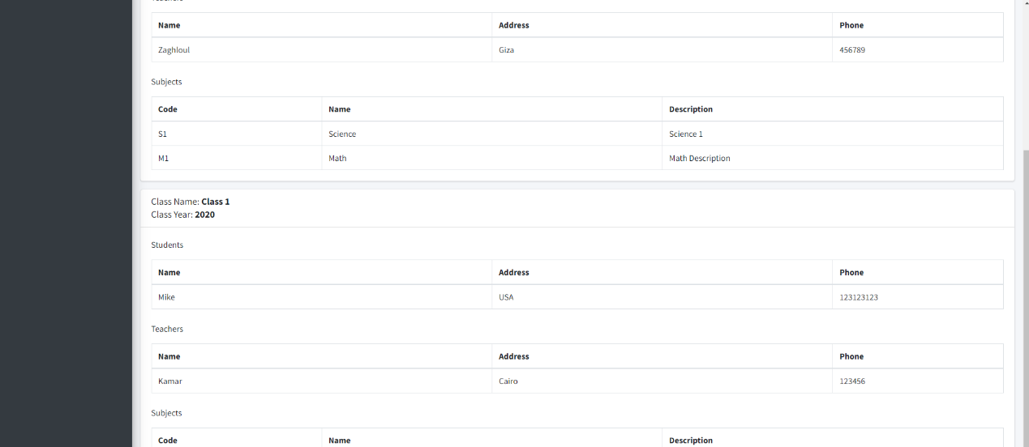

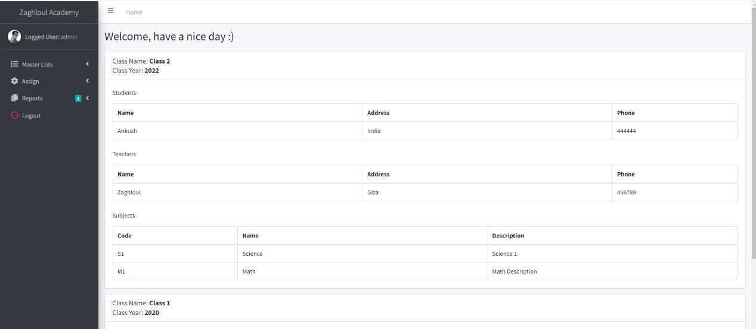

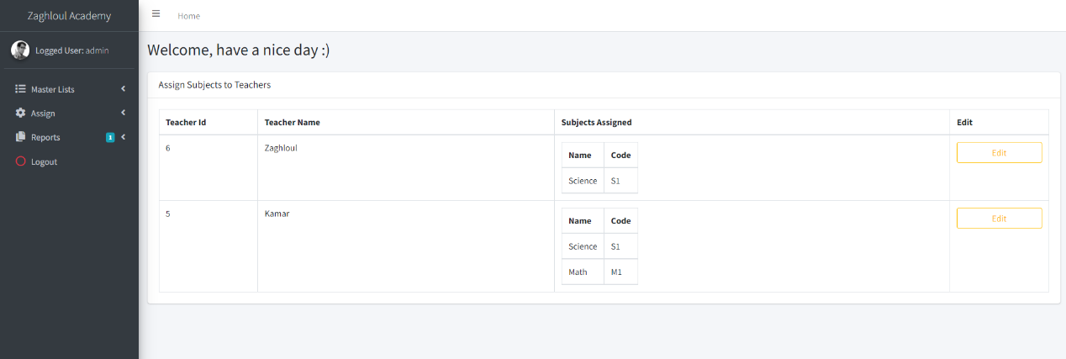

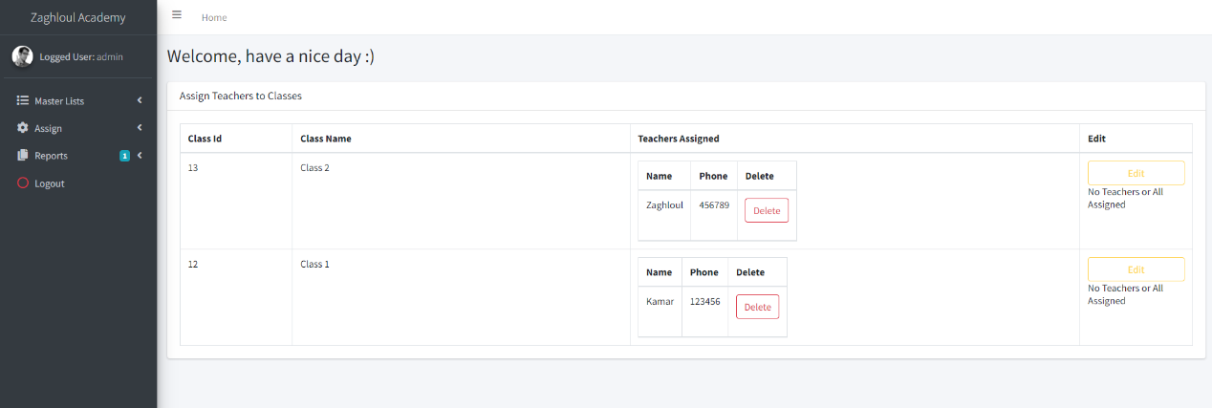

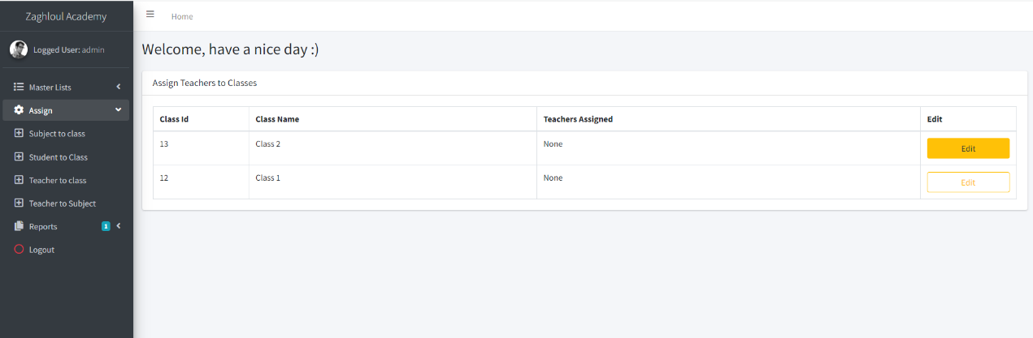

**Rest of screenshots can be found here:**

[**https://github.com/kamarz01/Simplilearn_Phase2_Learners_Acadmy_Admin_Backend/Screenshots**](https://github.com/kamarz01/Simplilearn_Phase2_Learners_Acadmy_Admin_Backend/Screenshots)

1. **Github Repo**

[**https://github.com/kamarz01/Simplilearn_Phase2_Learners_Acadmy_Admin_Backend**](https://github.com/kamarz01/Simplilearn_Phase2_Learners_Acadmy_Admin_Backend)